THE PARALYMPIC
GAMES
COMPUTER PROJECT 1

-Soha Sarmalker
10A, 27
2021-22
ACKNOWLEDGEMENT
I would like to express my special thanks of gratitude to my teacher Ms. Archana
Bandekar as well as our principal Ms. Sandhya Venkatesh who gave me the
golden opportunity to do this wonderful and interesting project on the topic “The
Paralympic Games”, which also helped me in doing a lot of research and I came to know
about so many new things, I am really thankful to them. Secondly, I would also like to
thank my parents and friends who helped me a lot in finalizing this project within the
limited time frame.

INDEX
Sr. No. | Content | Page no.
1 | Aim | 3
2 | Introduction | 4
3 | Software language used | 5
4 | Tags used+ Description | 6
5 | Html source codes of all webpages | 7-15
6 | Output | 16-18
7 | Conclusion+ Reference | 19

AIM
Webpage design inspired by various online encyclopedias, specifically providing
information on the Paralympic games. The webpages include Introduction,
origin of Paralympic games, categories of Paralympic athletes, various disabilities,
famous Paralympians around the world and India and much more.

INTRODUCTION
The Paralympics are games that allow athletes with disabilities to participate in an
international competition against athletes with similar or the same disabilities. There are five
different disability groups that are registered in the games. There are nineteen different sports,
four of which are unique to the Paralympics. This webpage will help those who want to know
more about the Paralympics!

SOFTWARE LANGUAGE USED
- HTML
- Web Browser
- Notepad

TAGS USED+DESCRIPTION
- <!--...-->: Defines a comment.
- <html>: Defines the root of an HTML document.
- <head>: Contains metadata/ information for the document.
- <title>: Defines a title for the document.
- <body>: Defines the document's body.
- <h1> to <h6>: Defines HTML headings.
- <img>: Defines an image.
- <font>: Defines font, color, and size for text.
- <p>: Defines a paragraph.
- <br>: Defines a single line break.
- <center>: Defines centered text.
- <b>: Defines bold text
- <i>: Defines italic text.
- <u>: Defines underlined text.
- <dd>: Defines a description/value of a term in a description list.
- <dt>: Defines a term/name in a description list.
- <hr>: stands for horizontal rule and is used to insert a horizontal rule or a thematic break.
- <li>: Defines a list item.
- <ol>: Defines an ordered list.
- <ul>: Defines an unordered list.
- <sub>: Defines subscripted text.
- <sup>: Defines superscripted text.

HTML SOURCE CODE OF PG1
<!--first page of computer project-->
<html>
<head>
<title>THE PARALYMPICS</title>
</head>
<body bgcolor="beige">
<hr color=indianred size=5 width=100% align=center>
<hr color=dodgerblue size=5 width=100% align=center>
<hr color=forestgreen size=5 width=100% align=center>
<h1 align=center><img src="logo.gif" width=100 height=80>
<font size="40" face="verdana" colour="white"><u>
THE PARALYMPIC GAMES</u></font><img src="logo.gif" width=100 height=80>
<h2 align="left">☆WHAT ARE THE PARALYMPICS?☆</h2>
<p><font size="5">The <b>Paralympic Games</b> or <b>Paralympics</b>, also known as <i>the Games
of the Paralympiad</i>, is a periodic series of international multi-sport events involving athletes with a range of disabilities, including
impaired muscle power, impaired passive range of movement, limb deficiency, leg length difference, short stature, hypertonia, ataxia, athetosis, vision impairment and intellectual impairment.</font></p>
<h3> <dt>PARALYMPICS<br>[Para·lym·pics]</dt>
<dd><i>: a series of international contests for athletes with disabilities that are associated with and held following the summer and winter Olympic Games.</i></dd>
</h3>
<center><img src="1.gif" width=500 height=300 border=5 vspace=10 ><br>
<font size="-1">(logo of the paralympic games is included in the title, the image above does
not depict the actual logo)</font></center>
<body bgcolor="beige">
<hr color=indianred size=5 width=100% align=center>
<hr color=dodgerblue size=5 width=100% align=center>
<hr color=forestgreen size=5 width=100% align=center>
</body>
</html>

HTML SOURCE CODE OF PG2
<!--second page of computer project-->
<html>
<head>
<title>THE PARALYMPICS</title>
</head>
<body bgcolor="beige">
<hr color=indianred size=5 width=100% align=center>
<hr color=dodgerblue size=5 width=100% align=center>
<hr color=forestgreen size=5 width=100% align=center>
<h1 align="center"><img src="logo.gif" align="left" width=60 height=50>
<font size="40" face="verdana" colour="white"><u>
HISTORY OF THE PARALYMPICS</u></font>
<img src="logo.gif" align="right" width=60 height=50>
<center><p><font size="5">Sport for athletes with an impairment has existed for more than 100 years!!<br>
The first sport clubs for the deaf were already in existence in 1888 in Berlin.
It was not until after World War II however, that it was widely introduced.
In 1944, at the request of the British Government, <b>Dr. Ludwig Guttmann </b>opened
a spinal injuries centre at the <b>Stoke Mandeville Hospital</b> in Great Britain, <br>
and in time, rehabilitation sport evolved to recreational sport and
then to competitive sport!</font></p></center>
<h2 align="left">☆STOKE MANDEVILLE GAMES☆</h2>
<p><font size="4">On 29 July 1948, the day of the Opening Ceremony
of the London 1948 Olympic Games, Dr. Guttmann organised the <i>first competition for
wheelchair athletes</i> which he named the Stoke Mandeville Games, a milestone in Paralympic history.
They involved <i>16 injured servicemen and women who took part in archery.</i> In 1952, Dutch ex-servicemen joined the Movement and the International Stoke Mandeville Games were founded</font></p>
<center><img src="2.gif" border=5 height=180 width=190 hspace=10><br>Dr. Ludwig Guttmann</center>
<h2 align="left">☆FIRST PARALYMPIC GAMES☆</h2>
<p><font size="4">The Stoke Mandeville Games later became the Paralympic Games which<i> first took place in Rome, Italy, in 1960 featuring 400 athletes from 23 countries. </i>Since then they have taken place every four years.
<br>In 1976 the first<i> Winter Games in Paralympics</i> history were held in Sweden, and as with the<i> Summer Games,</i> have taken place
every four years, and include a Paralympics Opening Ceremony and Paralympics Closing Ceremony.
<br>Since the Summer Games of Seoul, Korea in 1988 and the Winter Games in Albertville, France in 1992 the Games have also taken part in the same
cities and venues as the Olympics due to an agreement between the Internation Paralympic committee and International Olympic Committee.</font></p>
<center><img src="3.gif" border=5 height=300 width=500 hspace=10><br>Where it all started...</center>
<h2 align="left">☆BIRTH OF INTERNATIONAL PARALYMPIC COMMITTEE☆</h2>
<p><font size="4">On 22 September 1989, the International Paralympic Committee was founded as an international non-profit organisation in Dusseldorf,
Germany, to act as the <i>global governing body of the Paralympic Movement.</i>
The International Paralympic Committee is the global governing body of the
Paralympic Movement. It comprises 176 National Paralympic Committees
(NPC) and four disability-specific international sports federations.
The president of the IPC is <i>Andrew Parsons.</i><br>
The IPC is also needed to <i>supervise and coordinate the World Championships and other competitions</i> for each of the nine sports it regulates.
IPC membership also includes National Paralympic Committees and international sporting federations.
International Federations are independent sport federations recognized by the IPC as the sole representative of a Paralympic Sport. <br>International Federations responsibilities include technical jurisdiction and guidance
over the competition and training venues of their respective sports during the Paralympic Games.
The IPC also recognizes media partners, certifies officials, judges,
and is responsible for enforcing the<i> bylaws of the Paralympic Charter.</i><br>
<center><img src="4.gif" border=5 height=300 width=500 hspace=10><br>IPC headquarters in Bonn, Germany</center><br>
<i>The IPC has a cooperative relationship with the International Olympic Committee (IOC).</i> Delegates of the IPC are also members of the IOC and participate
on IOC committees and commissions. The two governing bodies remain distinct, with separate Games, despite
the close working relationship.</font></p>
<hr color=indianred size=5 width=100% align=center>
<hr color=dodgerblue size=5 width=100% align=center>
<hr color=forestgreen size=5 width=100% align=center>
</body>
</html>

HTML SOURCE CODE OF PG3
<!--third page of computer project-->
<html>
<head>
<title>THE PARALYMPICS</title>
</head>
<body bgcolor="beige">
<hr color=indianred size=5 width=100% align=center>
<hr color=dodgerblue size=5 width=100% align=center>
<hr color=forestgreen size=5 width=100% align=center>
<h1 align="center"><img src="logo.gif" align="left" width=60 height=50>
<font size="40" face="verdana" colour="white"><u>
THE PARALYMPIANS?</u></font>
<img src="logo.gif" align="right" width=60 height=50>
<h2 align="left">☆WHAT/WHO IS A PARALYMPIAN?☆</h2>
<h2> <dt>[Para·​lym·​pian]</dt>
<dd><i>:a competitor in the Paralympic Games is called a Paralympian. </i></dd>
</h2>
<h2 align="left">☆CATEGORIES EXPLAINED☆</h2>
<p><font size="4">The IPC has established ten disability categories, including physical, visual, and intellectual impairment. Athletes with one of these disabilities can compete in the Paralympics though not every sport can allow for every disability category. These categories apply to both Summer and Winter Paralympics.<br>
<ol type="1">
<li><u>Physical Impairment</u></li>
<ul type="disc">
<li><b>Impaired muscle power </b>– With impairments in this category, the force generated by muscles,
such as the muscles of one limb, one side of the body or the lower half of the body is reduced(e.g. spinal cord injury)</li>
<li><b>Impaired passive range of movement</b> – Range of movement in one or more joints is reduced
in a systematic way. Acute conditions such as arthritis are not included.</li>
<li><b>Loss of limb or limb deficiency </b>– A total or partial absence of bones or joints from partial
or total loss due to illness, trauma, or congenital limb deficiency.</li>
<li><b>Leg-length difference</b> – Significant bone shortening occurs in one leg due to congenital deficiency or trauma.</li>
<li><b>Short stature</b> – Standing height is reduced due to shortened legs, arms and trunk, which are due to a musculoskeletal deficit of bone or cartilage structures. </li>
<li><b>Hypertonia</b> – Hypertonia is marked by an abnormal increase in muscle tension and reduced ability of a muscle to stretch. Hypertonia may result from injury, disease, or conditions which involve damage to the central nervous system (e.g. cerebral palsy).</li>
<li><b>Ataxia</b> – Ataxia is an impairment that consists of a lack of coordination of muscle movements.</li>
<li><b>Athetosis</b> – Athetosis is generally characterized by unbalanced, involuntary movements and a difficulty maintaining
a symmetrical posture.</li>
</ul>
<li><u>Visual Impairment</u> – Athletes with visual impairment ranging from partial vision, sufficient to be judged legally blind, to total blindness.
The sighted guides for athletes with a visual impairment are such a close and essential part of themcompetition that the athlete with visual impairment and the guide are considered a team.</li>
<li><u>Intellectual Disability</u> – Athletes with a significant intellectual impairment and associated limitations in adaptive behaviour.This includes only elite athletes with intellectual disabilities diagnosed before the age of 18.
However, the IOC-recognized Special Olympics World Games are open to all people with intellectual disabilities.</li>
</ol></font></p>
<h2 align="left">☆FURTHER CLASSIFICATION?☆</h2>
<p><font size="4">Within the disability categories,<i> the athletes still need to be divided according to level of impairment.</i>
The classification systems differ from sport to sport and are intended to open up sports to as many athletes as possible who can participate in fair competitions against athletes with similar levels of ability.<i>The biggest challenge in the classification system is how to account for the wide variety and severity of disabilities.</i>
Consequently, there is a range of impairment within most classifications.</font></p>
<hr color=indianred size=5 width=100% align=center>
<hr color=dodgerblue size=5 width=100% align=center>
<hr color=forestgreen size=5 width=100% align=center>
</body>
</html>

HTML SOURCE CODE OF PG4
<!--fourth page of computer project-->
<html>
<head>
<title>THE PARALYMPICS</title>
</head>
<body bgcolor="beige">
<hr color=indianred size=5 width=100% align=center>
<hr color=dodgerblue size=5 width=100% align=center>
<hr color=forestgreen size=5 width=100% align=center>
<h1 align="center"><img src="logo.gif" align="left" width=60 height=50>
<font face="verdana"><u>
FAMOUS PARALYMPIANS AND THEIR ACHIEVEMENTS</u></font>
<img src="logo.gif" align="right" width=60 height=50></h1><br>
<ol type="1">
<li><u>TRISCHA ZORN</u></li><br>
<img src="5.gif" height=230 width=200 align="left" align="right" hspace=10 border=5><br>
<font size="5"> ★Born June 1, 1964 in Orange, California is an American Paralympic swimmer.<br>
★Blind from birth, she competed in Paralympic swimming.Despite her handicap, she was fast and
had precision in her swimming. Zorn is rated as one of the best athletes ever<br>
★She is the most successful athlete in the history of the Paralympic Games, having won 55 medals
(41 gold, 9 silver and 5 bronze), and was inducted into the Paralympic Hall of Fame in 2012.<br>
★She took the Paralympic Oath for athletes at the 1996 Summer Paralympics in Atlanta.</font><br><br><br>
<br><br><br><li><u>RAGNHILD MYKLEBUST</u></li><br>
<img src="6.gif" height=250 width=200 align="left" align="right" hspace=10 border=5><br>
<font size="5">★Ragnhild Myklebust is known as the queen of the Winter Paralympics because of her 22
gold medal victories. She was born on December 13th in the year 1943 and she is a Norwegian Nordic skier.<br>
★The skier Ragnhild is suffering from polio from her childhood to date. She is the record holder for the most
ever medals won at the Winter Paralympics with having 27 medals achieved and of which 22 are only gold medals.<br>
★ Myklebust has won Paralympic medals in short races, middle races, and long-distance races. Also, she has participated
in cross-country races, relays races, biathlon races, and ice sledge racing too.<br>
★ She was also honored with the Government Paralympic award and many more for her devotion and spirit for the sports.</font><br><br><br>
<br><li><u>SARAH STOREY(née Bailey)</u></li><br>
<img src="7.gif" height=280 width=250 align="left" align="right" hspace=10 border=5><br>
<font size="5">★Dame Sarah Joanne Storey, DBE was born on 26
October 1977, without a functioning left hand after her arm became entangled in the umbilical cord
in the womb and the hand did not develop as normal.<br>
★She is a British Paralympic athlete in cycling and swimming,
and a multiple gold medalist in the Paralympic Games, and six times British
(able-bodied) national track champion. Her total of 28 Paralympic medals including 17 gold medals makes
her the most successful (by gold medals) and most decorated (by total medal
s) British Paralympian of all time as well as one of the most decorated Par
alympic athletes of all time.<br>
★Storey's major achievements include being a 29-time World champion (6 in swimming and 23 in cycling), a 21-time European
champion (18 in swimming and 3 in cycling) and holding 75 world records.</font><br><br><br>
<br><br><li><u>JONAS JACOBSSON</u></li><br>
<img src="8.gif" height=290 width=250 align="left" align="right" hspace=10 vspace=10 border=5><br>
<font size="5">★Jonas Jacobsson, born on 22 June 1965, is a Swedish sport shooter who has won several
gold medals at the Paralympic Games. <br>
★Jonas was born paralysed waist down but this didn't stop him from becoming one of the most
well known paralympic athlete.<br>
★He participated in ten consecutive Summer Paralympics from 1980 to 2016, winning a total of
seventeen gold, two silver, and nine bronze medals.<br>
★On 10 September 2008 Jacobsson won his 16th gold medal in the Paralympic Games making him the
best performing male Paralympics contestant so far. Later that year,
he became the first athlete with a physical disability to receive the
Svenska Dagbladet Gold Medal, Sweden's most significant sports award.</font><br>
</ol>
<hr color=indianred size=5 width=100% align=center>
<hr color=dodgerblue size=5 width=100% align=center>
<hr color=forestgreen size=5 width=100% align=center>
</body>
</html>

HTML SOURCE CODE OF PG5
<!--fifth page of computer project-->
<html>
<head>
<title>THE PARALYMPICS</title>
</head>
<body bgcolor="beige">
<hr color=indianred size=5 width=100% align=center>
<hr color=dodgerblue size=5 width=100% align=center>
<hr color=forestgreen size=5 width=100% align=center>
<h1 align="center"><img src="logo.gif" align="left" width=60 height=50>
<font face="verdana"><u>
INDIANS AT THE PARALYMPICS</u></font>
<img src="logo.gif" align="right" width=60 height=50></h1><br>
<ol type="1">
<li><u>DEVENDRA JHAJARIA</u></li><br>
<img src="9.gif" height=260 width=220 align="left" align="right" hspace=10 border=5><br>
<font size="5"> ★Devendra Jhajharia, born 10 June 1981, is an Indian
Paralympic javelin thrower competing in F46 events. At the age of eight, climbing a
tree he touched a live electric cable. He received medical attention but
the doctors were forced to amputate his left hand.<br>
★He won his 1<sup>st</sup> gold in the javelin throw at the 2004 Summer Paralympics
in Athens, becoming the second gold medalist at the Paralympics for his
country. At the 2016 Summer Paralympics in Rio de Janeiro, he won a
2<sup>nd</sup> gold medal in the same event, bettering his previous record.
Devendra is currently being supported by the Olympic Gold Quest.
He becomes India's most decorated Paralympic player by winning his
3<sup>rd</sup> medal, a silver at the 2020 Summer Paralympics at Tokyo.<br>
★He is a recipient of prestigious awards like the Padmashri and Arjuna award.</font>
<br><br><br>
<li><u>DEEPA MALIK</u></li><br>
<img src="10.gif" height=260 width=220 align="left" align="right" hspace=10 border=5><br>
<font size="5">★Deepa Malik, born in 30 September 1970, is an Indian athlete.
She had to undergo a surgery, to remove a tumour in the spinal cord,
which was potentially life-threatening, she is paralysed waist down and uses
a wheelchair.<br>
★Deepa Malik is the first Indian woman to win a medal at the Paralympics.
She won the silver medal in the shot put in 2016 Paralympic Games.<br>
★She was previously honored with the Arjuna award in 2012, at the age of
42 years. She has also been conferred the prestigious Padma Shri award
in 2017. She created a New Asian Record in Asian Para Games 2018 and is the
only Indian woman to win medals in 3 consecutive Asian Para Games (2010,
2014, 2018). She has won 58 national & 23 International medals across
all disciplines to date.</font><br><br>
<br><br> <li><u>MARIYAPPAN THANGAVELU</u></li><br>
<img src="11.gif" height=260 width=220 align="left" align="right" hspace=10 vspace border=5><br>
<font size="5">★Mariyappan Thangavelu, born 28 June 1995, is an Indian
Paralympic high jumper. He suffered permanent disability in his right leg
after it was crushed under a bus when he was only five years old.<br>
★He represented India in the 2016 Summer Paralympics games held in Rio de
Janeiro in the men's high jump T-42 category and the 2020 Summer Paralympic
games held in Tokyo in the men's high jump T-63 category , winning the gold
medal and silver medal respectively in the finals.
He is India's first Paralympian gold medalist since 2004.<br>
★On 25 January 2017, Government of India conferred him with the Padma Shri
award for his contribution towards sports and in the same year he was
also awarded Arjuna Award. He was awarded with Major Dhyan Chand
Khel Ratna in the year 2020 by Government of India.</font>
</ol><br><br>
<h1 align="center"><img src="logo.gif" align="left" width=60 height=50>
<font face="verdana"><u>
WHY PARALYMPICS?</u></font>
<img src="logo.gif" align="right" width=60 height=50></h1><br>
<h2 align="left">☆THE PURPOSE OF PARALYMPICS☆</h2>
<font size="5">To promote and contribute to the development of sport opportunities
and competitions, from the start to elite level. To
develop opportunities for athletes with a severe
disability in sport at all levels and in all
structures.</font>
<h1 align="center">THANK YOU!</h1>
<hr color=indianred size=5 width=100% align=center>
<hr color=dodgerblue size=5 width=100% align=center>
<hr color=forestgreen size=5 width=100% align=center>
</body>
</html>

OUTPUTS
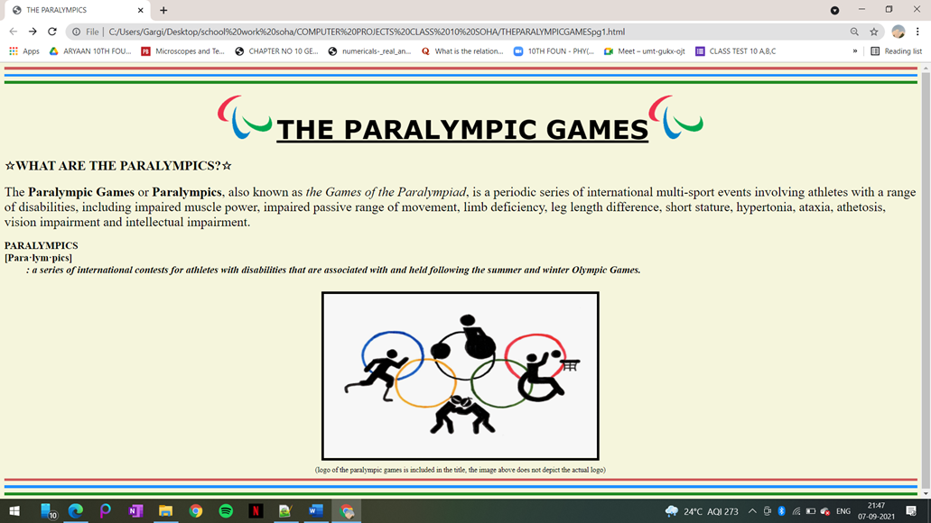

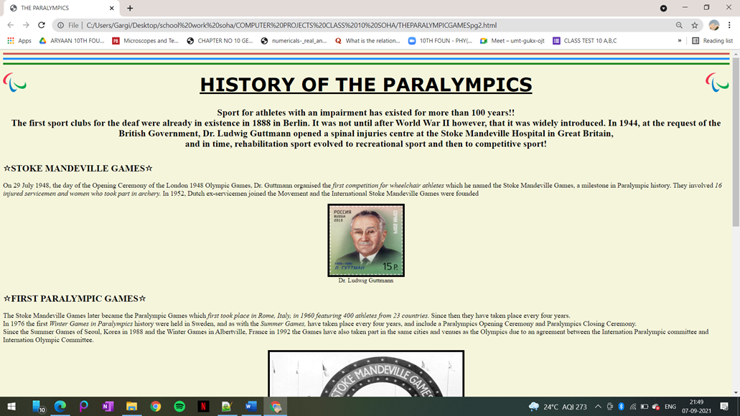

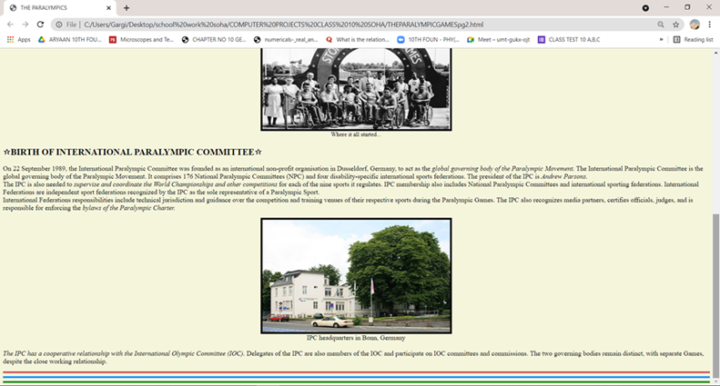

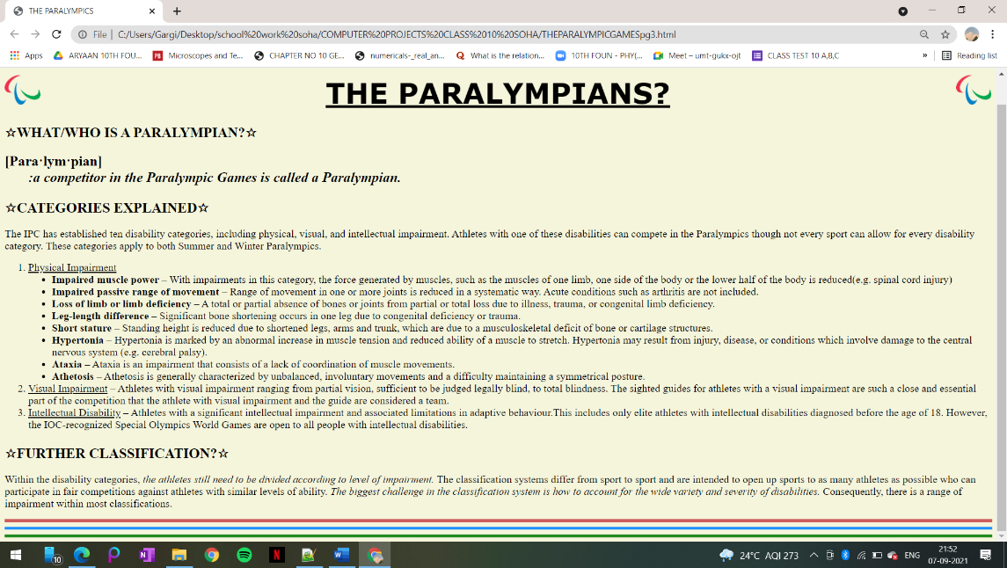

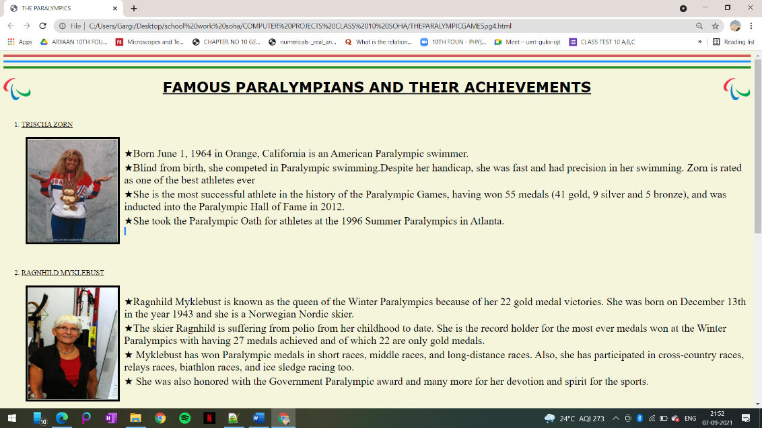

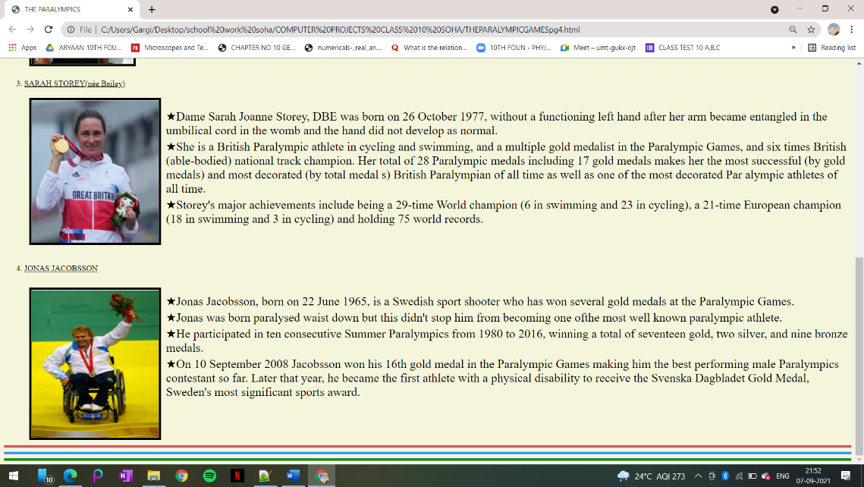

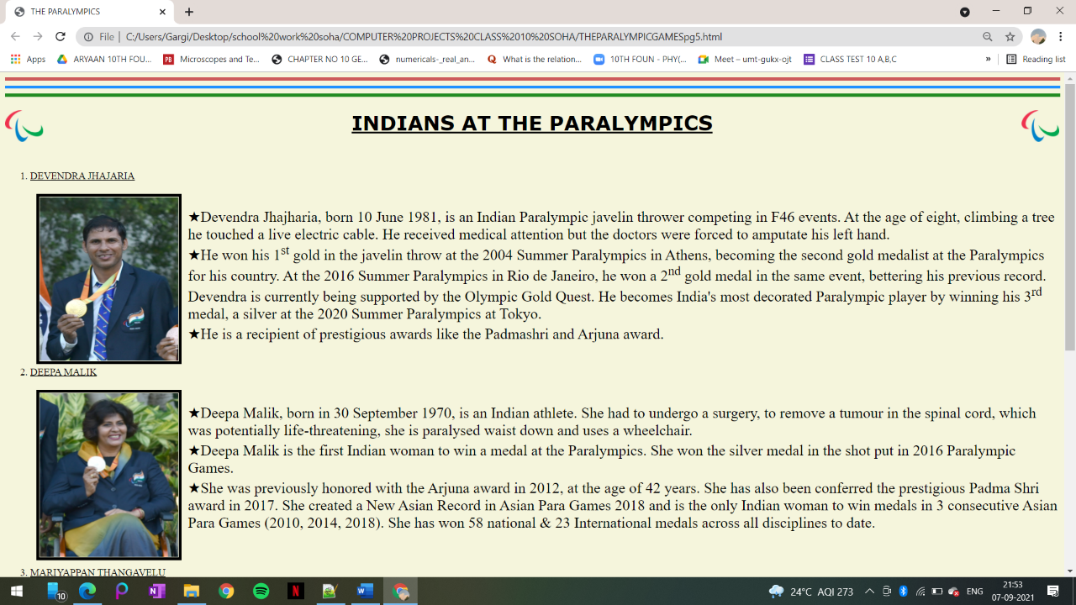

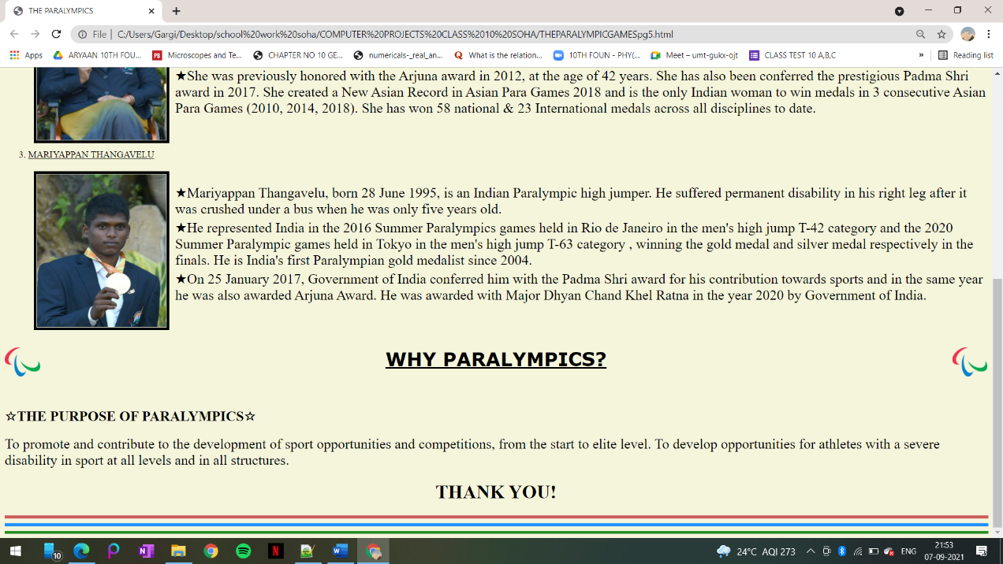

CONCLUSION
Sports does not know discrimination and the Paralympics, since its inception, has been a step forward in promoting inclusivity and unification through sports.
The Paralympic Games are not only an integral part of the worldwide sporting calendar, but they also play an important role in inspiring others to think differently about disability as the largest event worldwide for driving social change. They display great determination and courage to overcome mental and physical obstacles. They are truly inspirational because they prove that few things are impossible. The Paralympics also raise awareness of mental and physical disabilities in the hope of creating a better life for those with disabilities.

REFERENCES
Paralympic Games - Wikipedia
Paralympics History - Evolution of the Paralympic Movement | International Paralympic Committee
HTML Reference
Essay On The Paralympics - 1380 Words | 123 Help Me

THANK YOU!

